Table 1

Coding Scheme

|  |  |  |
| --- | --- | --- |
| Category | Definition | Indicator/example |
| Cognitive | Statements directly related to on-task content of group assignment | - sharing knowledge;  - comparing information on facts;  - suggesting opinion on the assigned topics;  - brainstorming, questioning, refining, elaborating;  - suggested ideas with real life examples;  - evaluating by agreeing or disagreeing with each other;  - integrating and synthesizing the conflicted opinions; |
| Social | Statements to build up friendship and group membership | - salutation: greetings, calling names, conventional thanks;  - openness: self-introduction, sharing personal feeling/emotional states;  - humour, jokes  - encouragement/compliments (e.g., good work! Great team!)  - off-task information: statements not directly related to the course content or tasks, general information |
| Managerial | Statements to manage the collaborative processes | - scheduling (e.g., I will post my work by 11am tomorrow);  - dividing jobs;  - arranging meetings  - clarifying ambiguities and procedures about assignments (e.g., deadlines, word limits, technological problems)  - discussing strategies (e.g., Let’s post work individually and combine the works.) |

Table 2

*Messages coded and analyzed*

|  |  |  |  |
| --- | --- | --- | --- |
| Activity | No. of Messages | No. of Units | No. of Words |
| Whole group Module 1 | 106 | 316 | 7533 |
| Whole group Module 2 | 74 | 246 | 9868 |
| Small groups Activity | 652 | 2434 | 58912 |
| Total data coded | 832 | 2996 | 76313 |

Table 3

*Correlations between Small-group and Whole-class communication*

|  |  |  |  |  |  |  |  |  |  |
| --- | --- | --- | --- | --- | --- | --- | --- | --- | --- |
| Activity | Whole-group | | | | | | Small-group | | |
| Whole-group discussion | Category | | Cognitive | | Social | | Cognitive | Social | Managerial |
| Out | In | Out | In | Out | Out | Out |
| Cognitive | Out | - | 0.49 | 0.61* | 0.29 | 0.40 | 0.45 | 0.31 |
| In | 0.49 | - | 0.74** | 0.67* | 0.11 | 0.25 | 0.47 |
| Social | Out | 0.61* | 0.74** | - | 0.56 | 0.14 | 0.69* | 0.79** |
| In | 0.29 | 0.67* | 0.56 | - | 0.32 | 0.41 | 0.57 |

*Note*: *p<.05 (r=0.576, p=0.05), **p<0.001 (r=0.708, p=0.01); Out: messages sent out to other students; In: messages received from other students

Table 4

*Measure of group collaboration based on amount of words sent during small group activity*

|  |  |  |  |  |  |  |  |  |  |  |  |  |
| --- | --- | --- | --- | --- | --- | --- | --- | --- | --- | --- | --- | --- |
| Measure index | Quantity  (total words) | | | | Equality  (std. deviation, words) | | | | Shareness  (sent to all: %) | | | |
| Small-groups | 1 | 2 | 3 | 4 | 1 | 2 | 3 | 4 | 1 | 2 | 3 | 4 |
| Cognitive | 5432 | 4721 | 8510 | 6548 | 545 | 518 | 334 | 800 | 38 | 63 | 91 | 91 |
| Managerial | 4545 | 6150 | 5072 | 4298 | 1149 | 1456 | 717 | 1178 | 46 | 56 | 65 | 62 |
| Social | 2731 | 4233 | 2187 | 4485 | 409 | 778 | 278 | 790 | 39 | 56 | 51 | 52 |
| Average/Overall | 4236 | 5035 | 5256 | 5110 | 2,014 | 2,716 | 773 | 2,551 | 41 | 58 | 69 | 68 |

*Note*: Quantity: total exchanged words, Equality: group standard deviation of exchanged words; Shareness: per cent of the exchanged words to all other members of total exchanged words

Table 5

*Group Ranking Measured by Collaboration Indexes and Achievement Marks*

|  |  |  |  |  |
| --- | --- | --- | --- | --- |
|  | Group 1 | Group 2 | Group 3 | Group 4 |
| Quantity | 4 | 3 | 1 | 2 |
| Equality | 2 | 4 | 1 | 3 |
| Shareness | 4 | 3 | 1 | 2 |
| Overall collaboration | **3** | **3** | **1** | **2** |
| Achievement | 3 | 3 | 1 | 2 |

Table 6

*Amount of Communication Sent by Individual Members Contributing Group Collaboration*

|  |  |  |  |  |  |
| --- | --- | --- | --- | --- | --- |
| Category  Students | | Cognitive | Managerial | Social | Total |
| Group 1 | 14M1 | 2123 | 1297 | 861 | 4281 |
| 15M1 | 1181 | 491 | 528 | 2200 |
| 16F1 | 2128 | 2757 | 1342 | 6227 |
| Total | 5432 | 4545 | 2731 | 12708 |
| Group 2 | 17F2 | 1055 | 1037 | 718 | 2810 |
| 18F2 | 2090 | 3719 | 2252 | 8061 |
| 19M2 | 1576 | 1394 | 1263 | 4233 |
| Total | 4721 | 6150 | 4233 | 15104 |
| Group 3 | 20F3 | 3172 | 1047 | 416 | 4635 |
| 21F3 | 2504 | 1561 | 947 | 5012 |
| 22F3 | 2834 | 2464 | 824 | 6122 |
| Total | 8510 | 5072 | 2187 | 15769 |
| Group 4 | 23M4 | 2854 | 1244 | 1567 | 5665 |
| 24M4 | 1297 | 360 | 671 | 2328 |
| 25F4 | 2397 | 2694 | 2247 | 7338 |
| Total | 6548 | 4298 | 4485 | 15331 |
| Grand Total | | 25221 (43%) | 20065 (34%) | 13636 (23%) | 58912 |

Table 7

*Correlations of Small-group communication*

|  |  |  |
| --- | --- | --- |
| Category | Social | Managerial |
| Cognitive | 0.19 | 0.36 |
| Social | - | **0.77\*\*** |

*Note*: *p<.05 (r=0.576, p=0.05), **p<0.001 (r=0.708, p=0.01)

**Coding the data** (Interpretive coding) & **Revising the coding framework** (Inductive coding)

Compare the coding results between independent coders (MS word)

Export to database (MySQL)

Import data to SPSS 8.0, UCINET 6.0, and Excel Programs for analysis

Adjusting the disagreement

Develop coding framework and a codebook with examples/indicators: Henri (1992), Garrison (1992), Hara, Bonk, Angeli (2000), and Newman, Webb and Cochrane (1995)

**Data collection:**

* Ethical review process
* Data compiling (course instructor)
* Transferring (MET Program Assistant)



*Figure 1.* Data processing for coding and analysis

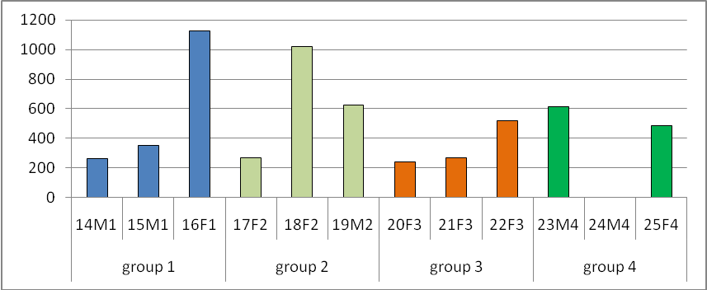

*Figure 2.* Amount of Words Sent for Self-Introduction Module 1 as the Whole-group

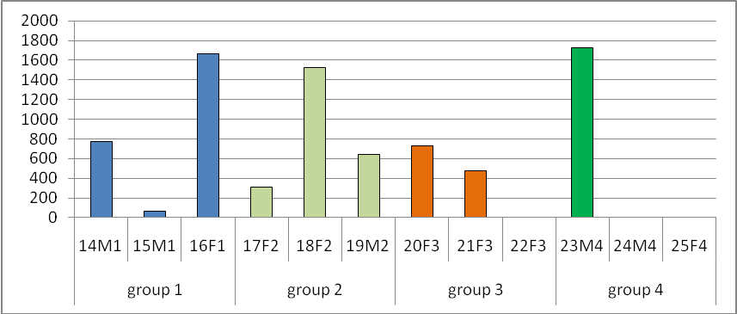

*Figure 3.* Amount of Words Sent for a Topic Discussion Module 2 as the Whole-group

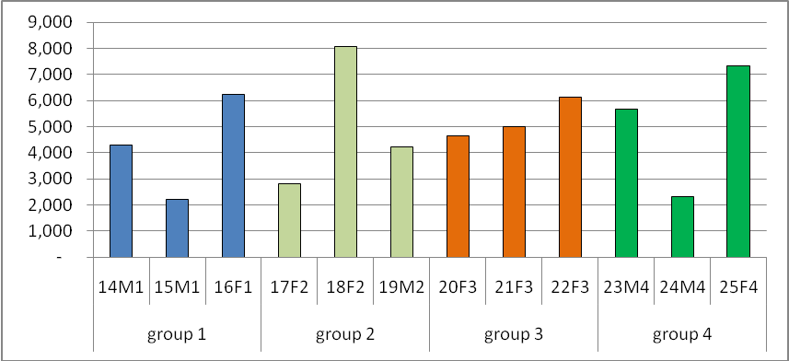

*Figure 4.* Amount of Words Sent for Small-group Activity

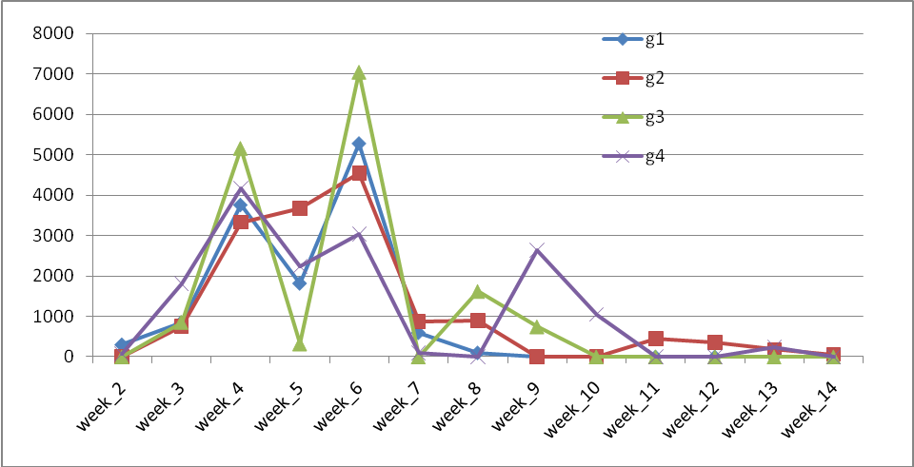

*Figure 5.* Total messages exchanged during small group activity

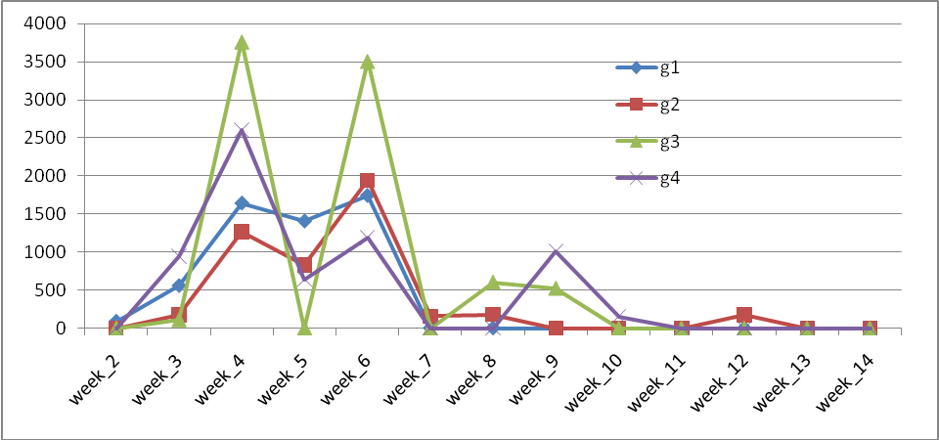

*Figure 6.* Cognitive messages exchanged during small group activity

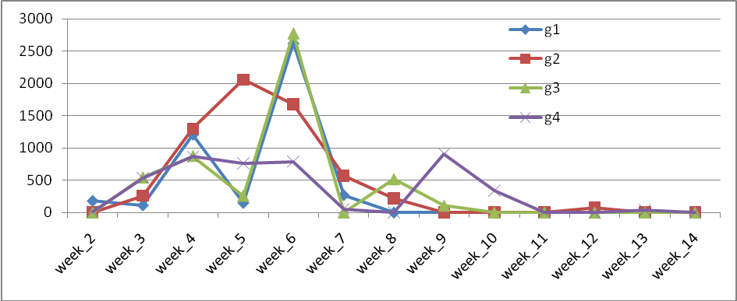

*Figure 7.* Managerial messages exchanged during small group activity

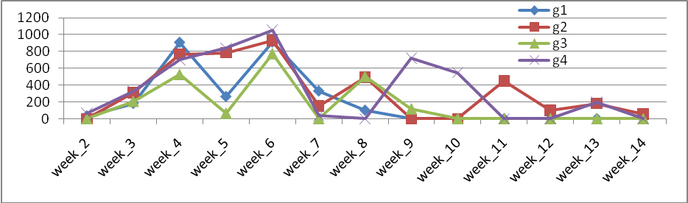

*Figure 8.* Social messages exchanged during small group activity